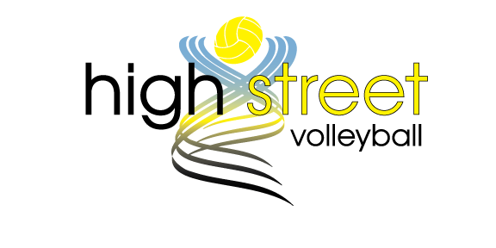

ASSUMPTION OF RISK AND RELEASE FROM LIABILITY AGREEMENT

PLEASE READ CAREFULLY

THIS IS A LEGAL DOCUMENT. By signing it, you are limiting your ability to recover from High Street Athletics and its affiliates any damages you sustain while at High Street Athletics or its affiliate locations. If you have any questions about the legal consequences of this document, please obtain advice from your legal counsel prior to signing. This document must be signed before you participate in any activity at High Street Athletics or its affiliate locations or partners. You agree not to sue High Street Athletics, its affiliates or partners for any claims you may have.

In consideration for permitting Participant to participate at High Street Athletics, its affiliates or partners as either a participant, volunteer, spectator, coach, assistant coach, manager, or any role that requires participation at the High Street Athletics facility or its affiliate or partners facilities, the undersigned, for themselves, and for their respective heirs, personal representatives and assigns, agree as follows:

I HEREBY ASSUME ALL OF THE RISKS OF PARTICIPATING IN ANY/ALL ACTIVITIES ASSOCIATED WITH THIS EVENT, including by way of example and not limitation, any risks that may arise from negligence or carelessness on the part of the persons or entities being released, from dangerous or defective equipment or property owned, maintained, or controlled by them, or because of their possible liability without fault.

I certify that I am physically fit, have sufficiently prepared or trained for participation in this activity, and have not been advised to not participate by a qualified medical professional. I certify that there are no health-related reasons or problems which preclude my participation in this activity.

I acknowledge that upon any concussion or head trauma related symptoms or injuries, or if any member at High Street Athletics has reason to believe you have sustained a concussion or head injury, you will follow the rules, policies and regulations as set forth in High Street’s concussion protocol and waive and release any liability in the treatment and care for a possible head injury, including, but not limited to, contacting 911 emergency ambulatory services, application of a head and/or spine brace, removal from any athletic related activity immediately and the authority to communicate with your emergency contact to transport you to a hospital or medical facility for further evaluation and/or treatment.

I acknowledge that this Assumption of Risk and Release of Liability Agreement will be used by High Street Athletics, its affiliates, partners, the event holders, sponsors, and organizers of the activity in which I may participate, and that it will govern my actions and responsibilities at said activity.

(A) I WAIVE, RELEASE, AND DISCHARGE from any and all liability, including but not limited to, liability arising from the negligence or fault of the entities or persons released, for my death, disability, personal injury, property damage, property theft, or actions of any kind which may hereafter occur to me including my traveling to and from this activity, THE FOLLOWING ENTITIES OR PERSONS: High Street Athletics, its affiliate locations, partners, and/or their directors, officers, employees, volunteers, representatives, and agents, and the activity holders, sponsors, and volunteers;

(B) INDEMNIFY, HOLD HARMLESS, AND PROMISE NOT TO SUE the entities or persons mentioned in this paragraph from any and all liabilities or claims made as a result of participation in this activity, whether caused by the negligence of release or otherwise.

I acknowledge that High Street Athletics, its affiliate locations, partners and their directors, officers, volunteers, representatives, and agents are NOT responsible for the errors, omissions, acts, or failures to act of any party or entity conducting a specific activity on their behalf.

I acknowledge that this activity may involve a test of a person's physical and mental limits and carries with it the potential for death, serious injury, and property loss. The risks include, but are not limited to, those caused by terrain, facilities, temperature, weather, condition of participants, equipment, vehicular traffic, lack of hydration, and actions of other people including, but not limited to, participants, volunteers, monitors, and/or producers of the activity. These risks are not only inherent to participants, but are also present for volunteers, coaches, managers, spectators, or any role that requires participation at High Street Athletics, or its affiliate locations or partners.

Participant agrees to give up their right to a trial by a court or a jury. Any dispute or claim between participant and High Street Athletics, its affiliates or partners, including those arising out of or related to this Agreement, the interpretation of this Agreement, or any damages, shall be settled by binding arbitration in accordance with the Rules of the American Arbitration Association. The arbitrator’s award shall be final and binding upon the parties, and judgment upon the award may be entered by any court of competent jurisdiction. The place of arbitration shall be the county or jurisdiction where High Street Athletics, its affiliates or partners are located.

High Street Athletics, its affiliate locations and partners shall not be liable for the loss or theft of, or damage to, the personal property of any participant, member, guest, volunteer, coach, manager, spectator, or any person on the premises of High Street Athletics, its affiliate locations, or partners.

I hereby consent to receive medical treatment which may be deemed advisable in the event of injury, accident, and/or illness during this activity.

I understand while participating in this activity, I may be photographed. I agree to allow my photo, video, or film likeness to be used for any legitimate purpose by the activity holders, producers, sponsors, organizers, and assigns.

The Assumption of Risk and Release of Liability Agreement shall be construed broadly to provide a release and waiver to the maximum extent permissible under applicable law.

I CERTIFY THAT I HAVE READ THIS DOCUMENT AND I FULLY UNDERSTAND ITS CONTENT. I AM AWARE THAT THIS IS A RELEASE OF LIABILITY AND A CONTRACT AND I ACCEPT THE TERMS OF MY OWN FREE WILL.

